

**SADAF IQBAL**

**56352**

**SE-03**

**COAL**

**LAB TAKS**

**Task # 01**

.model small

.stack 100h

.data

.code

Main Proc

mov ah,1

int 21h

sub al,'0'

mul al

AAM

mov ch,ah

mov cl,al

mov dl,10

mov ah,2

int 21h

mov dl,13

mov ah,2

int 21h

mov dl,ch

add dx,48

mov ah,2

int 21h

mov dl,cl

add dx,48

mov ah,2

int 21h

mov ah,4ch

int 21h

main endp

end main

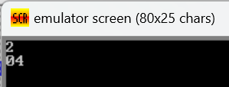

**Task # 02**

.model small

.stack 100h

.data

.code

Main Proc

mov ah,1

int 21h

sub al,'0'

mov bl,al

mul bl

mul bl

AAM

mov ch,ah

mov cl,al

mov dl,10

mov ah,2

int 21h

mov dl,13

mov ah,2

int 21h

mov dl,ch

add dx,48

mov ah,2

int 21h

mov dl,cl

add dx,48

mov ah,2

int 21h

mov ah,4ch

int 21h

main endp

end main

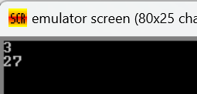

**Task # 03**

.model small

.stack 100h

.data

.code

main proc

mov ah,1

int 21h

mov bl,al

sub bl,48

mul bl

mov dl,'*'

mov ah,2

int 21h

mov ah,1

int 21h

mov cl,al

mov dl,'='

mov ah,2

int 21h

sub cl,48

mov al,bl

mul cl

AAM

mov ch,ah

mov cl,al

mov dl,ch

add dl,48

mov ah,2

int 21h

mov dl,cl

add dl,48

mov ah,2

int 21h

mov ah,4ch

int 21h

main endp

end main

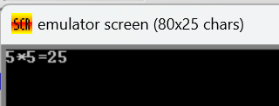

**Task # 04**

.model small

.stack 100h

.data

.code

main proc

mov ah,1

int 21h

mov bl,al

sub bl,48

mov ah,1

int 21h

mov dl,al

sub cl,48

mov al,bl

mov bl,2

mul cl

div bl

mov dl,al

add dl,48

AAM

mov ch,ah

mov cl,al

mov dl,ch

add dl,48

mov ah,2

int 21h

mov dl,cl

add dl,48

mov ah,2

int 21h

mov ah,4ch

int 21h

main endp

end main

